Soulmate
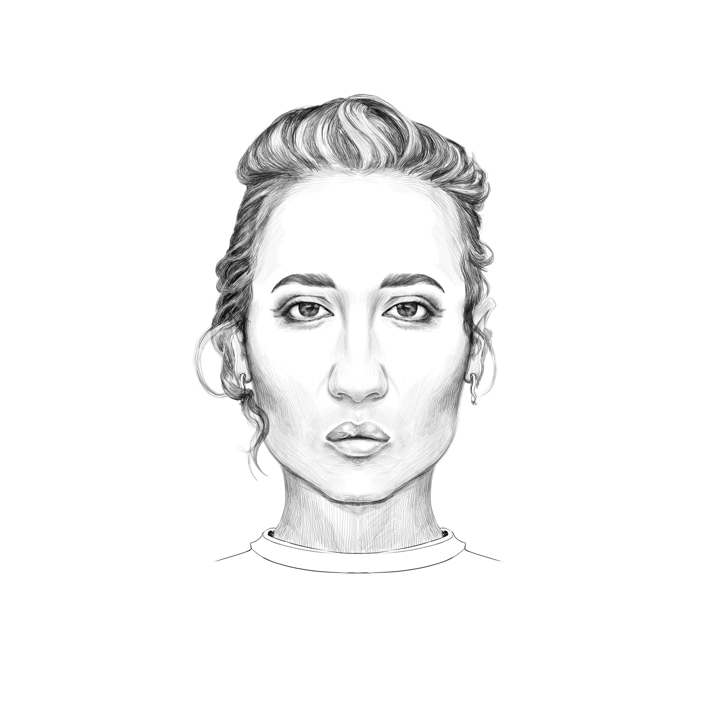
Here you can find a picture of my soulmate.
But I dont know where she is living.
Maybe she is our Mother Earth.
Or is she only mine!
I hope that one day I find her, face to face.

