Facebook
https://www.facebook.com/sanne.andi.bild
Yes I have also an Facebook account, but I don't have any other account in Facebook any more this electronic reality.
I had also account https://www.facebook.com/anti.puusepp but there is already full with 45oo+ friends, so please be patient with me. I may not have time for all of you to chat.
But forgive me, I like you all, and I want to be friends with everybody living in this world.
And when everybody living in this world will be friends with everybody in this world were all be free to walk around the globe.
And then there is no wars, no pain, no stupiness, no …
Or maybe one day there may be also the Instagram account also, but it not exist yet, or I think at the moment it's not existing yet.
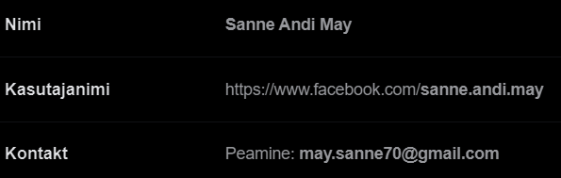
— 14.12.2021

